**Marietta Middle School**

121 Winn St. NW

Marietta, GA 30064

(770) 422 - 0311

SGT Minutes

**Date: March 2, 2022 Time: 7:50 am**

**Location:** Marietta Middle Heather’s Office

| **Attendees** | | | |
| --- | --- | --- | --- |
| Diona Brown | Heather Welch | Marshai Waiters  On field trip | Bella Gay |
| John Silvey | Erika Rodriguez | Tangela Jones | Emily Gross |

**Action Items**

| Norms | |
| --- | --- |
| Start on time | Consistency of meeting days/ times |
| Valuing each person’s time | Assume good will |
| Be present and focused | Be professional |
| Think through the lens of “is this what’s best for students?” | |

1. **Action Items** 
   1. Approve Minutes, motion by Ms. Jones and seconded
   2. Follow up on dress code policy - effective? Adjustments? Consequences for being coded 3 times?
   3. After-school tutoring and spring break programs
   4. Discipline- fighting is down
   5. Budget update
      1. Use remaining funds to support conferences and PD for travel Motion to approve funds toward this initiative - Silvey and Jones
      2. Ipads, furniture (innovation)
   6. Instructional Plans for Next Year
      1. Big Three - change from assessments to School culture (relationships being established between students/teachers)
      2. CTAE Courses
         1. Construction
         2. Architecture/ Interior Design
         3. Graphic Design/ Animation (Carthers at the HS)
      3. Science Labs (renovate?)
      4. Cafeteria (innovative space)

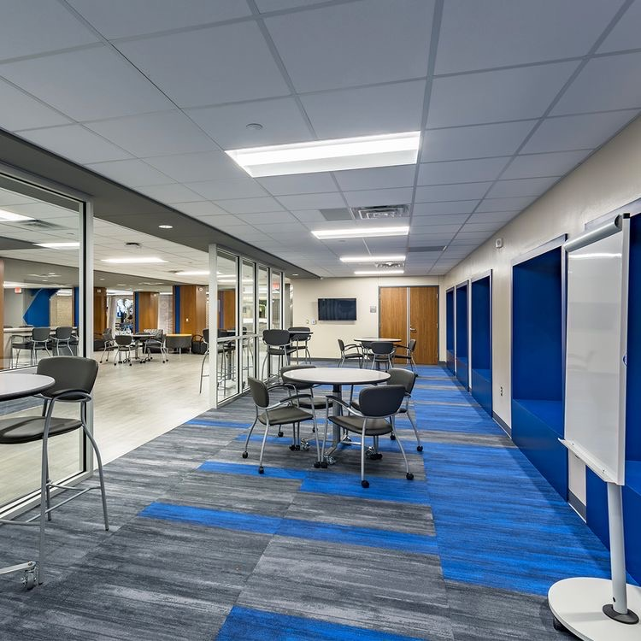

1. **Set Agenda for next meeting**
   1. Determine next meeting Apr 13, 2023
   2. Wrap up of the year
   3. Plans for next year
   4. Chromebooks
2. **Adjournment**

Motion to adjourn by Ms. Jones and seconded by Ms. Gross